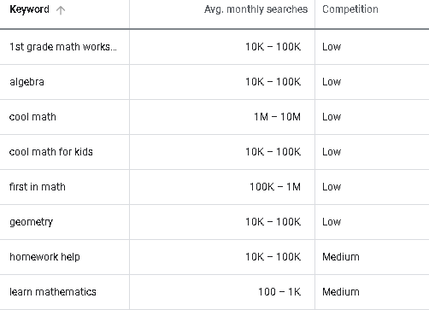

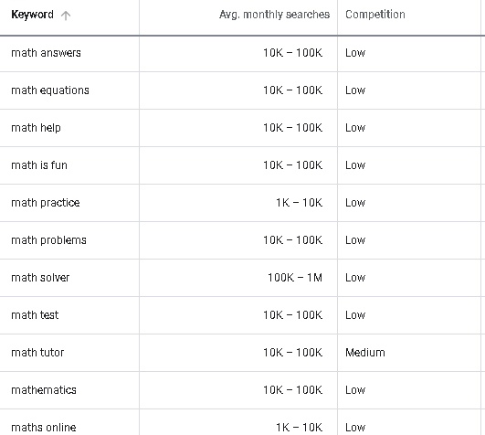

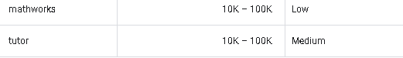

**Suggested Website title: Math is Fun - Easy Maths Online Grade A Method with Tutor Sotiris Deli**